The goal of this exercise is to analyze the pdf of the output of a logarithmic detector when its input is a white Gaussian noise (something similar to what we did at exercise 6.1).

Consider an in-phase Gaussian noise vector (zero mean) ni and a quadrature Gaussian noise vector (zero mean) nq, each one with 1 μW power and having a length of 20 000 samples. Once the vectors are ready, calculate the output of a logarithmic detector as the one in the figure. Use Matlab function log to perform the natural logarithm.

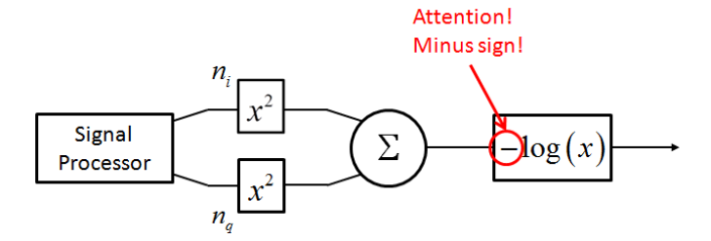



Then:

1. Make a histogram or pdf of the in-phase and quadrature noise vector and justify that the plot is as expected (at least use 100 bins to plot the histogram/pdf).

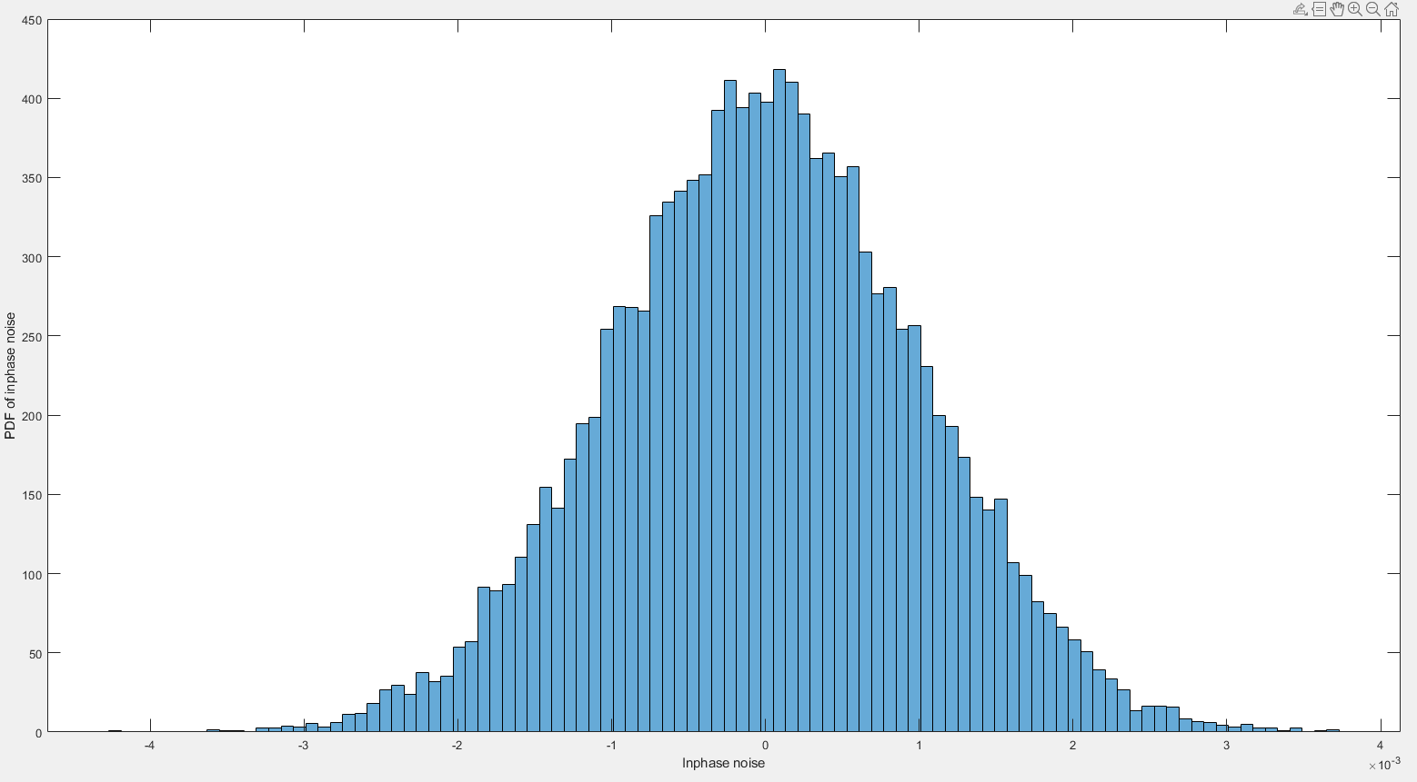

**Inphase Noise**

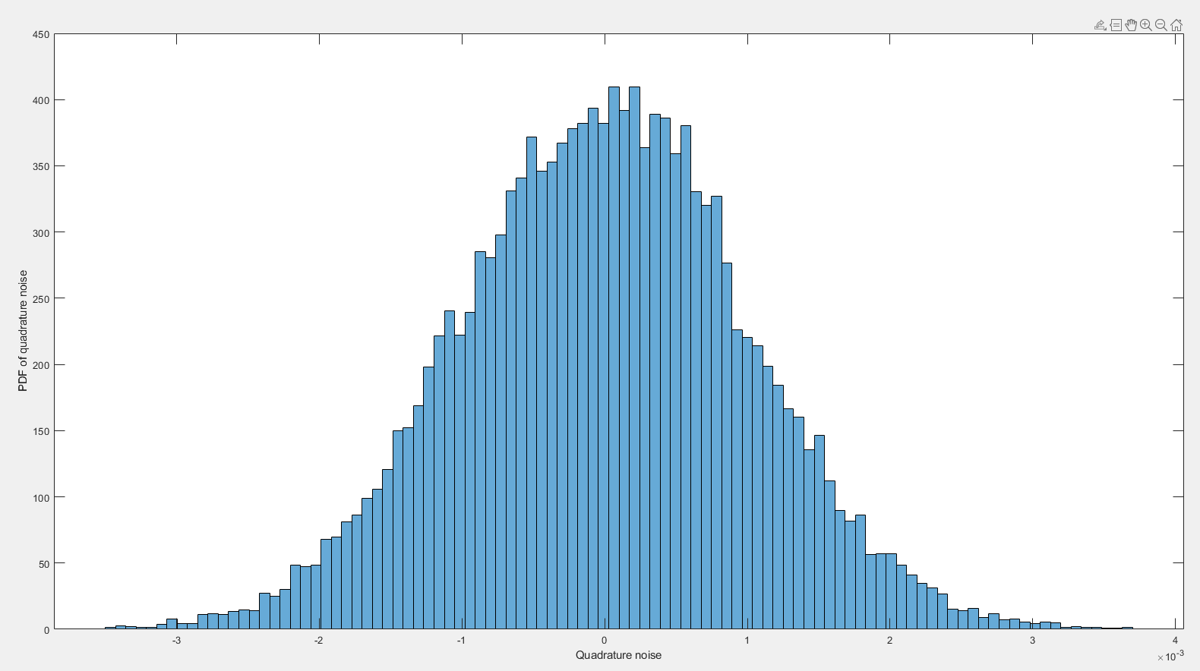

Quadrature Noise

Both the quadrature noise and in phase noise, remain unaffected as they are the input before the detector. As such the log law detector doesn’t affect them. And thus we expected gaussian noise and that is what we obtained.

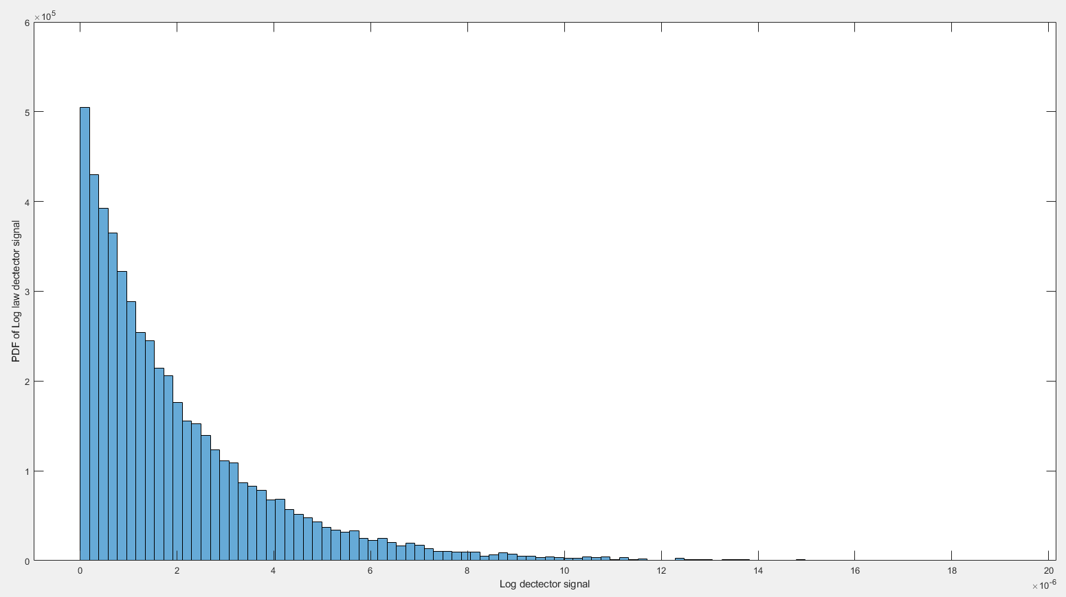

And as we can observer it is exactly what we observer from a log law detector, negative log.

1. Make a histogram/pdf of the output vector from the detector.



And as we can observer it is exactly what we observer from a log law detector, negative log.